Project Development Phase Sprint-2 Test Cases

|  |  |
| --- | --- |
| Date | 08 November 2022 |
| Team ID | PNT2022TMID22019 |
| Project Name | Virtual Eye - Life Guard for Swimming Pools to Detect Active Drowning |
| Maximum Marks | 8 Marks |



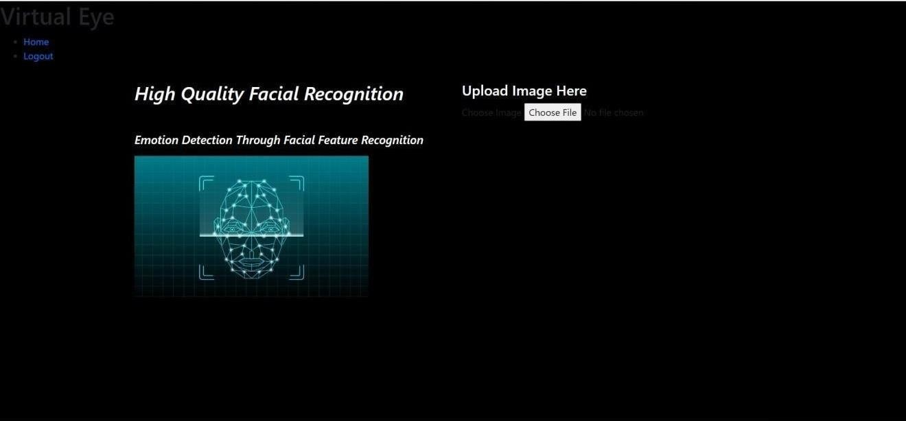

 



ABOUT PROJECT 

Problem: Solution:

pooham!oundlageonnumbemn tehowh.weekend oursspo0andbardypeopeha lther Ihehumanlé.ByJudpngbodymovemenIpa8ernsandsonneñngzamera ‹oanad0oa'ne f'9en=

hpuse back yard Beginners, @ pe<iaily every feeI it difiicult to bi eathe under water and causes bi bathing (At)5ystem we ran device arj underwa ley pool safety system that red y<es the risk of drowsy ing Usualiy ow i gproduces a higher raw oT such system s can be developed by installing more thanks cameras underwater and ceiling and analyse ng

g plea ‹ tion <

ktop/4W/nxlev amp a+es/predUon h+rrd

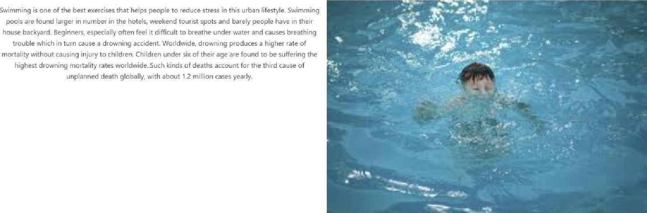Virtual Eye- Life Guard *or Swimming Pools to Detect Active Drowning